EXPERIMENT 4

Jai Prasadh

PHY 115L

INTRODUCTION

In this experiment I sought to learn about vibrations of a coupled oscillator. I first explored the individual oscillations of each mass and spring in the system and calculated the spring constant of each spring. I then focused on the coupled oscillations, both in the superposition of the two normal modes and in each normal mode in isolation. I aimed to experimentally determine the frequency and ratio of amplitudes of the masses in each normal mode.

RESULTS

Individual Oscillations:

I studied mass-and-spring set #3 in this experiment. I hung the heavier of the two masses, , from the stiffer spring () and the lighter mass, , from the looser spring (). For each, I excited a small amplitude oscillation and determined the period and frequency of oscillation. I then calculated each spring constant using the relation that spring constant is equal to the mass times the square of the frequency. My results for the values of the spring constants are as follows.

I then analyzed videos of the same oscillations in Tracker to determine the frequencies and compare to my initial result. My results for these frequencies are below, and figures 1 and 2 show the Fourier transforms for the individual oscillations of and , respectively.

|  |  |  |
| --- | --- | --- |
|  | Calculated from period | Determined from video analysis |
|  |  |  |
|  |  |  |

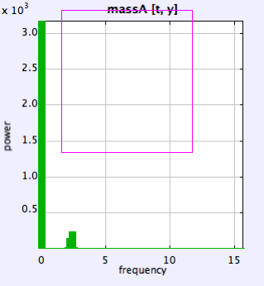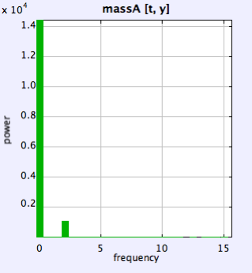

Figure 1 Figure 2

The frequencies determined via both methods generally agree.

Coupled Oscillations:

At this point, I hung the masses and springs in the order stiffest spring, heaviest mass, lighter spring, lighter mass. I excited a superposition of normal modes by holding the bottom mass fixed and stretching the top mass by a modest amount, then releasing both simultaneously with no initial velocity. Figure 3 shows the plot of this oscillation using a camera tracking the lower mass.

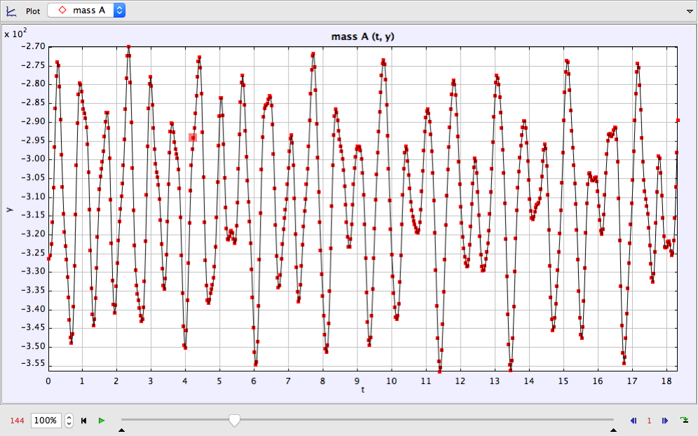

Figure 3

The movement looked quite chaotic, but there was some definite periodicity to the motion. The motion seems to follow some complicated variation on the harmonic function. I analyzed this motion and created a Fourier transform which I used to estimate the normal mode frequencies of the coupled system. I also calculated the normal mode frequencies from the known masses and spring constants, using the theoretical relation, as follows.

|  |  |  |
| --- | --- | --- |
| Mode | Observed Frequency (Rad/s) | Theoretical Frequency (Rad/s) |
| 1 |  |  |
| 2 |  |  |

It is evident that the observed values from the FFT are starkly different from what I would expect given the theory, so this leads me to believe that there is a large error somewhere in the apparatus. I noticed that the oscillating system had a not insignificant component of its motion in the x-direction in addition to the motion of interest in the y-direction, and I suspect this caused some unpredicted behavior of the masses’ motions.

Unfortunately, I did calculate the theoretical normal mode frequencies until later, so in trying to isolate the normal modes individually using a magnetic drive, I was using the faulty values of frequency given by the FFT. This resulted in my failure to isolate each normal mode. I did calculate the amplitude ratios of the two masses at each frequency I drove the system at, 5.8 Rad/s and 9.2 Rad/s, but since these aren’t the true normal mode frequencies, the amplitude ratios don’t demonstrate anything notable.

Figures 4 and 5 show the motion of masses 1 and 2, respectively in the lower frequency I drove the system at, 5.8 Rad/s.

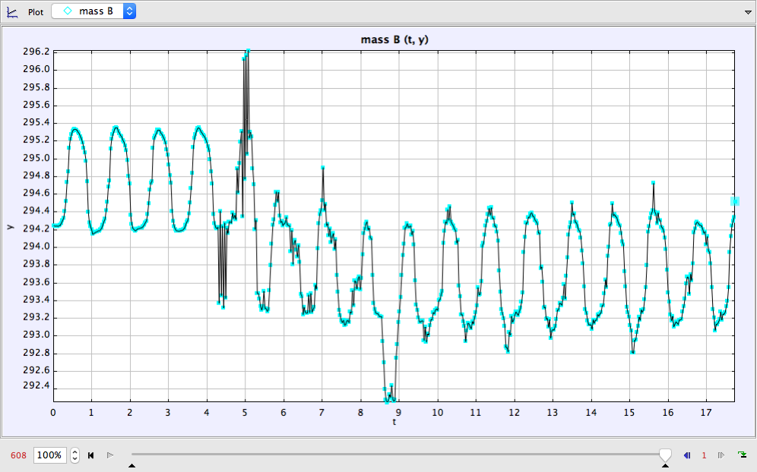

Figure 4

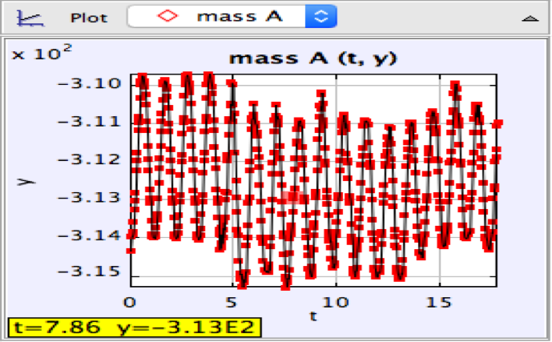

Figure 5

From a cursory glance, these motions look erratic and unexpected, which makes sense given that this was not at a true normal mode frequency.

Figures 6 and 7 show the motion of masses 1 and 2, respectively in the higher frequency I drove the system at, 9.2 Rad/s.

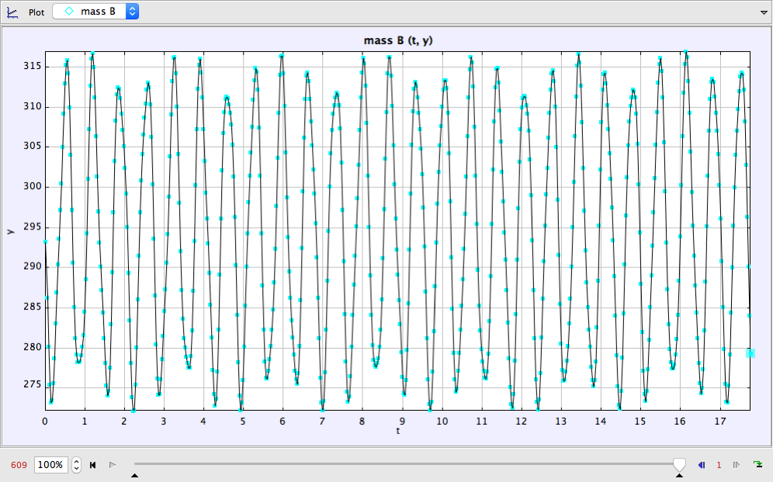

Figure 6

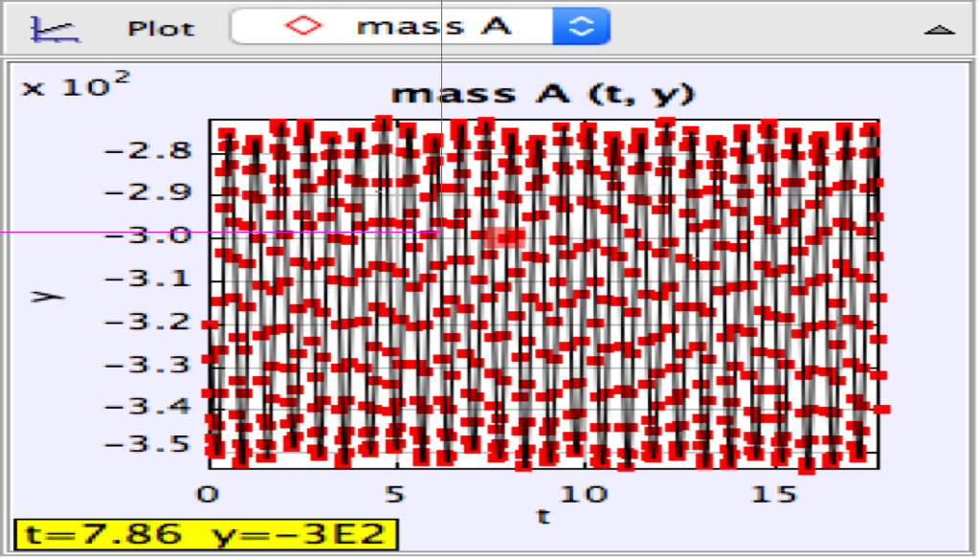

Figure 7

At each of these two incorrect “normal modes,” I calculated the amplitude ratio based on fits to the motions of each mass and compared the values to the theoretical amplitude ratios (at the true normal mode frequencies.) My results are as follows.

|  |  |  |
| --- | --- | --- |
| Mode | Observed Amplitude Ratio | Theoretical Amplitude Ratio |
| 1 |  |  |
| 2 |  |  |

Of course, the ratios I observed were not the true normal mode amplitude ratios since I drove the system at the erroneous normal mode frequencies produced by the FFT of the superposed oscillation.

Qualitatively, what I would have expected given my theoretical understanding is that in the lower normal mode, the masses should’ve oscillated together in phase but with varying amplitudes while in the higher normal mode, the masses would’ve oscillated radians out of phase, at a higher frequency, but still with varying amplitudes.

SUMMARY

My results for the individual oscillators agreed with my theoretical prediction, but my results for the coupled system did not, since my system’s coupled oscillation had some degree of two-dimensional oscillation which complicated the theory involved. In the single oscillator case, I was able to measure the spring constants and frequency of oscillation two different ways in agreement, using both a stopwatch-based approach and a video analysis approach, confirming my theoretical understanding of simple harmonic oscillations. In the coupled portion, my oscillator displayed significant tendency to vibrate in both horizontal and vertical directions, where the oscillation was intended to be purely in the vertical direction. This resulted in me being unable to observe normal mode frequencies and amplitude ratios which matched what I theoretically predicted. A question for future could be in what way does horizontal motion affect the theory for the vertical coupled oscillator and at what threshold of horizontal motion does this effect become significant.